ATHLETIC PERFORMANCE CAMP 21
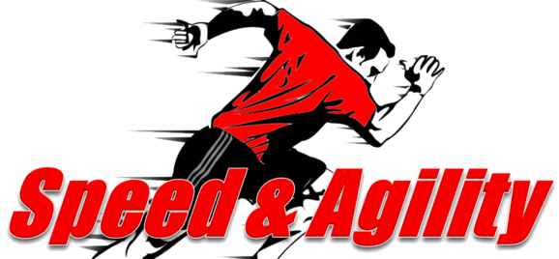

4 WEEK PROGRESSIVE PROGRAM INCLUDING:
A. CORE STRENGTH / ENDURANCE
B. MUSCULAR STRENGTH / ENDURANCE
C. EXPLOSIVE POWER
D. BALANCE

CAMP DATES
MAY 2, 2021
MAY 9, 2021
MAY 16, 2021
MAY 23, 2021
CAMP TIMES
10am -11:30 pm AGES 10-12; 12pm – 1:30pm AGES 13 and up
LOCATION: CACTUS PARK ( CACTUS & SCOTTSDALE RD)

Hosted by
Robert Lutfy(boblutfy@gmail.com)
BJ Bennett(bjbennett@athleticacademydynasty.com)
*Pre-registration (all 4 progressive camps) $175
*Day of first camp (all 4 camps) $200

